For Loop Problems

1. Use a for loop to display the numbers from 1 to 1000;

**for (int i=0; i<=1000; i++){**

**System.out.println(i);**

**}**

1. Use a for loop to add the numbers from -10 to 10. Display the sum at the end.

**int sum = 0;**

**for (int i=-10; i<=10; i++){**

**sum += I;**

**}**

**System.out.println(sum);**

1. Use a for loop to count the number of numbers that are divisible by 3 or 5 in the range 1 to 1000.

**int count = 0;**

**for (int i=1; i<=1000; i++){**

**if ((i%3 == 0) && (i%5==0))**

**count++;**

**}**

**System.out.println(count);**

1. Use a for loop to count the number of ‘e’ in a string str.

**int count = 0;**

**for (int i=0; i<str.length(); i++){**

**if(str.charAt(i) == ‘e’)**

**count++;**

**}**

**System.out.println(count);**

1. Use a for loop to count the number of time the word “hello” is in a String str. Assume the String str is at least 5 characters.

**int count = 0;**

**for (int i=0; i < str.length() - 4; i++){ // 4 is one less than the length of hello**

**String temp = str.substring(i,i+5);**

**if (temp.equals(“hello”)**

**count++;**

**}**

**System.out.println(count);**

1. Use a for loop to display 5 random numbers from 1 to 10 to the screen.

**for (int i=1; i<=5; i++){**

**int randomNumber = (int)(Math.random()*10 ) + 1**

**System.out.println(randomNumber);**

**}**

1. Use two for loops to create a square that is n x n. The for loops will be nested (one inside the other).

**for (int i=1; i<=n; i++){**

**for (int j=1;j<=n;j++){**

**System.out.print(‘*’);**

**}**

**System.out.println();**

**}**

1. Use two for loops to create the 10 times table. Starts at 0 and goes until 10. You do NOT need to put the numbers 0 through 10 at the top or on the left side of your table.

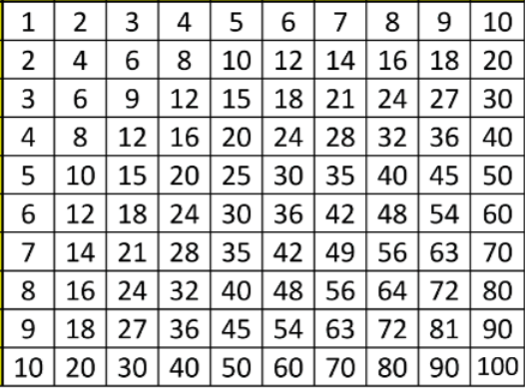

**for (int i=1; i<=10; i++){**

**for (int j=1;j<=10;j++){**

**System.out.printf("%5d",(i*j));}**

**System.out.println();**

**}**